# Add eMS core NuGet package to eMS solution

1. Open eMS project using the visual studio.
2. Click on Tools -> NuGet Package Manager -> Package Manager Settings

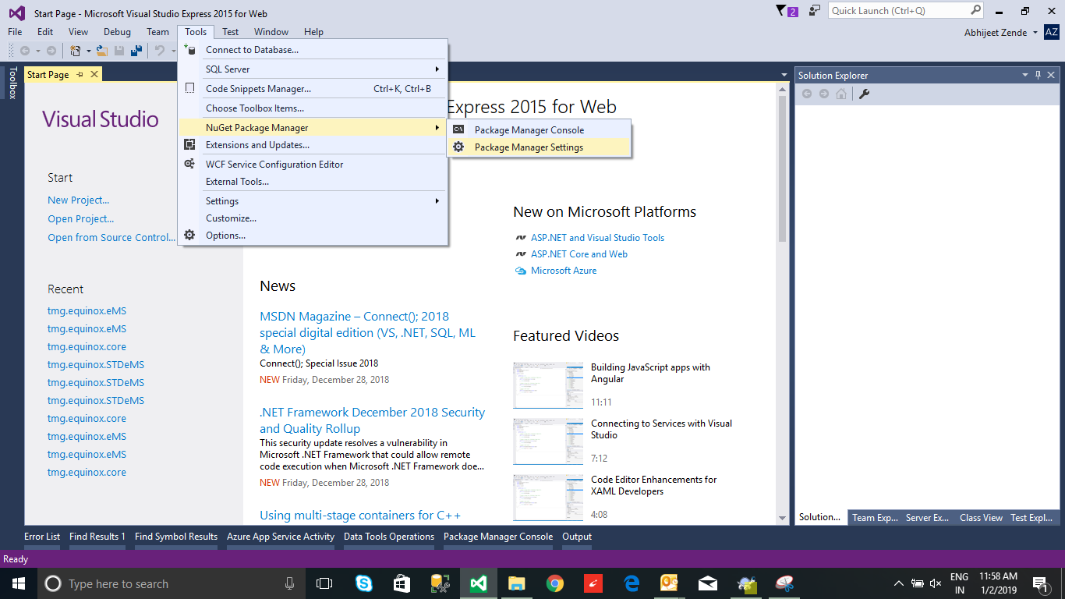

1. Popup will open as below snap. Click on + icon to add new package source. In the source textbox put <http://192.168.100.4:3636/nuget/> click Ok.

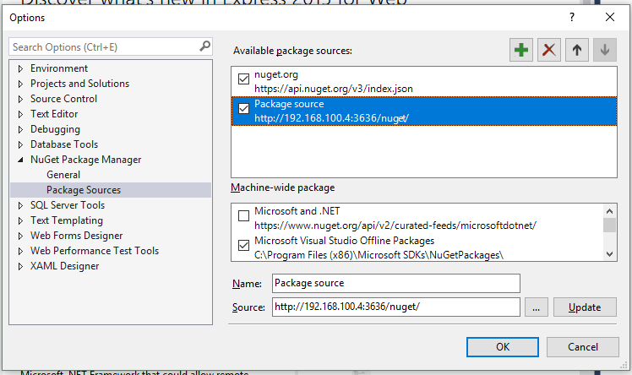

1. Go to solution. Right click solution -> select Manage NuGet Packages, In the Package source select “Package source”. You can see the tmg.equinox.core (Version = V1.0.0). Install this package.

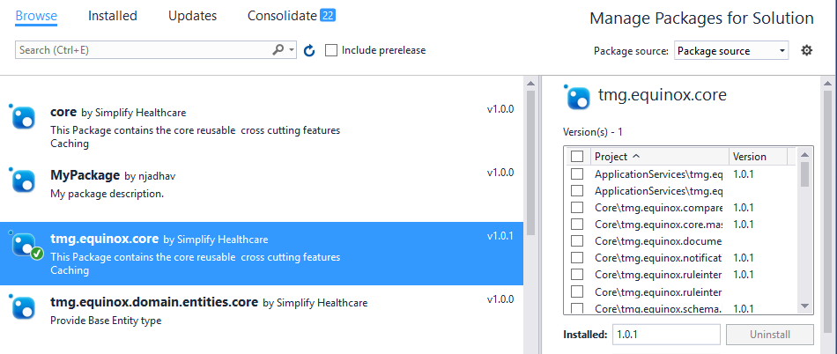

1. Rebuild the code.